Class-attribute-link-condition queries
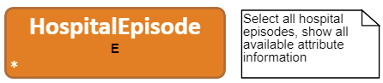 | PREFIX : <http://lumii.lv/ontologies/2016/mini-bkus-en#>  SELECT ?caseRecordNo ?totalCost ?lengthInDays ?dischargeReason ?dischargeTime ?admissionTime WHERE{  ?E a :HospitalEpisode.  OPTIONAL{?E :caseRecordNo ?caseRecordNo.}  OPTIONAL{?E :totalCost ?totalCost.}  OPTIONAL{?E :lengthInDays ?lengthInDays.}  OPTIONAL{?E :dischargeReason ?dischargeReason.}  OPTIONAL{?E :dischargeTime ?dischargeTime.}  OPTIONAL{?E :admissionTime ?admissionTime.}}
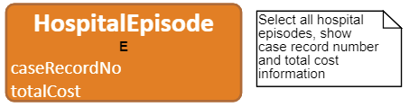 | PREFIX : <http://lumii.lv/ontologies/2016/mini-bkus-en#>  SELECT ?caseRecordNo ?totalCost WHERE{  ?E a :HospitalEpisode.  OPTIONAL{?E :caseRecordNo ?caseRecordNo.}  OPTIONAL{?E :totalCost ?totalCost.}}
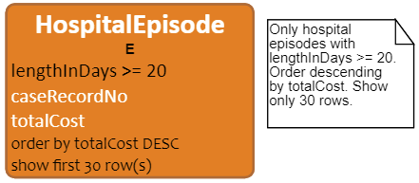 | PREFIX : <http://lumii.lv/ontologies/2016/mini-bkus-en#>  SELECT ?caseRecordNo ?totalCost WHERE{  ?E a :HospitalEpisode.  OPTIONAL{?E :caseRecordNo ?caseRecordNo.}  OPTIONAL{?E :totalCost ?totalCost.}  FILTER(EXISTS{?E :lengthInDays ?lengthInDays.  FILTER(?lengthInDays >= 20)})}  ORDER BY DESC(?totalCost)  LIMIT 30
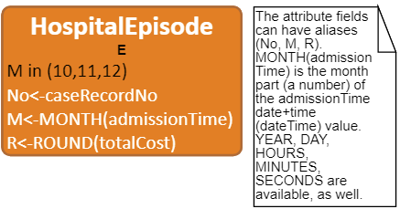 | PREFIX : <http://lumii.lv/ontologies/2016/mini-bkus-en#>  SELECT ?No ?M ?R WHERE{  ?E a :HospitalEpisode.  OPTIONAL{?E :caseRecordNo ?No.}  OPTIONAL{?E a :HospitalEpisode.  ?E :admissionTime ?admissionTime_1.  BIND(MONTH(?admissionTime_1) AS ?M)}  OPTIONAL{?E :totalCost ?totalCost_1.}  BIND(ROUND(?totalCost_1) AS ?R)  FILTER(?M IN (10, 11, 12))}
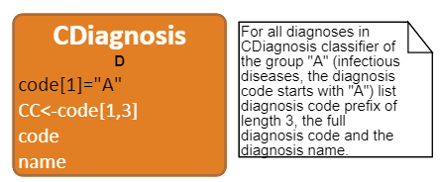 | PREFIX : <http://lumii.lv/ontologies/2016/mini-bkus-en#>  SELECT ?CC ?code ?name WHERE{  ?D a :CDiagnosis.  OPTIONAL{?D :code ?code.}  OPTIONAL{?D :name ?name.}  OPTIONAL{?D :code ?code_1.}  BIND(bif:substring(?code_1, 1, 3) AS ?CC)  FILTER(bif:substring(?code, 1, 1) = "A")}
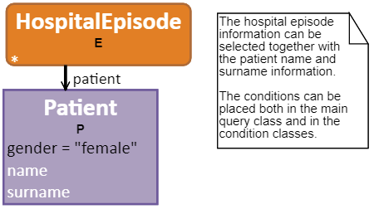 | PREFIX : <http://lumii.lv/ontologies/2016/mini-bkus-en#>  SELECT ?caseRecordNo ?totalCost ?lengthInDays ?dischargeReason ?dischargeTime ?admissionTime ?name ?surname WHERE{  ?E a :HospitalEpisode.  OPTIONAL{?E :caseRecordNo ?caseRecordNo.}  OPTIONAL{?E :totalCost ?totalCost.}  OPTIONAL{?E :lengthInDays ?lengthInDays.}  OPTIONAL{?E :dischargeReason ?dischargeReason.}  OPTIONAL{?E :dischargeTime ?dischargeTime.}  OPTIONAL{?E :admissionTime ?admissionTime.}  ?P a :Patient.  OPTIONAL{?P :name ?name.}  OPTIONAL{?P :surname ?surname.}  ?E :patient ?P.  FILTER(EXISTS{?P :gender ?gender.  FILTER(STR(?gender) = "female")})}
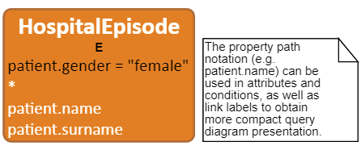 | PREFIX : <http://lumii.lv/ontologies/2016/mini-bkus-en#>  SELECT ?caseRecordNo ?totalCost ?lengthInDays ?dischargeReason ?dischargeTime ?admissionTime ?name ?surname WHERE{  ?E a :HospitalEpisode.  OPTIONAL{?E :caseRecordNo ?caseRecordNo.}  OPTIONAL{?E :totalCost ?totalCost.}  OPTIONAL{?E :lengthInDays ?lengthInDays.}  OPTIONAL{?E :dischargeReason ?dischargeReason.}  OPTIONAL{?E :dischargeTime ?dischargeTime.}  OPTIONAL{?E :admissionTime ?admissionTime.}  OPTIONAL{?E :patient/:name ?name.}  OPTIONAL{?E :patient/:surname ?surname.}  FILTER(EXISTS{?E :patient/:gender ?gender.  FILTER(STR(?gender) = "female")})}
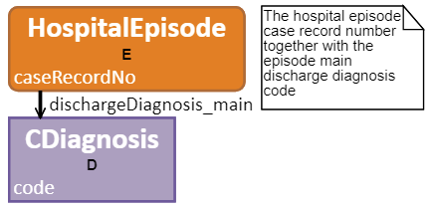 | PREFIX : <http://lumii.lv/ontologies/2016/mini-bkus-en#>  SELECT ?caseRecordNo ?code WHERE{  ?E a :HospitalEpisode.  OPTIONAL{?E :caseRecordNo ?caseRecordNo.}  ?D a :CDiagnosis.  OPTIONAL{?D :code ?code.}  ?E :dischargeDiagnosis_main ?D.}
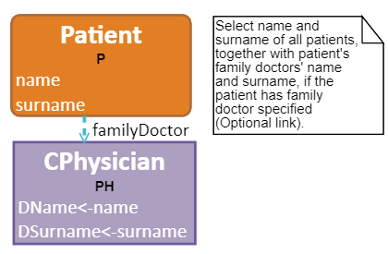 | PREFIX : <http://lumii.lv/ontologies/2016/mini-bkus-en#>  SELECT ?name ?surname ?DName ?DSurname WHERE{  ?P a :Patient.  OPTIONAL{?P :name ?name.}  OPTIONAL{?P :surname ?surname.}  OPTIONAL{?PH a :CPhysician.  OPTIONAL{?PH :name ?DName.}  OPTIONAL{?PH :surname ?DSurname.}  ?P :familyDoctor ?PH.}}
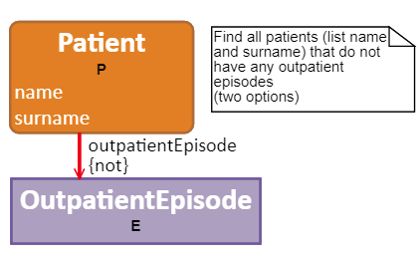 | PREFIX : <http://lumii.lv/ontologies/2016/mini-bkus-en#>  SELECT ?name ?surname WHERE{  ?P a :Patient.  OPTIONAL{?P :name ?name.}  OPTIONAL{?P :surname ?surname.}  FILTER NOT EXISTS{?E a :OutpatientEpisode.  ?P :outpatientEpisode ?E.}}
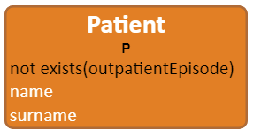 | PREFIX : <http://lumii.lv/ontologies/2016/mini-bkus-en#>  SELECT ?name ?surname WHERE{  ?P a :Patient.  OPTIONAL{?P :name ?name.}  OPTIONAL{?P :surname ?surname.}  FILTER(NOT EXISTS{?P :outpatientEpisode ?outpatientEpisode. })}
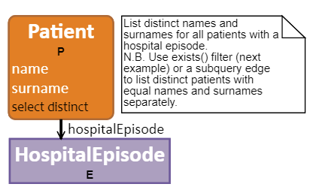 | PREFIX : <http://lumii.lv/ontologies/2016/mini-bkus-en#>  SELECT DISTINCT ?name ?surname WHERE{  ?P a :Patient.  OPTIONAL{?P :name ?name.}  OPTIONAL{?P :surname ?surname.}  ?E a :HospitalEpisode.  ?P :hospitalEpisode ?E.}
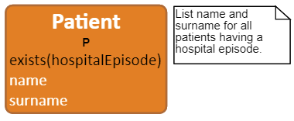 | PREFIX : <http://lumii.lv/ontologies/2016/mini-bkus-en#>  SELECT ?name ?surname WHERE{  ?P a :Patient.  OPTIONAL{?P :name ?name.}  OPTIONAL{?P :surname ?surname.}  FILTER(EXISTS{?P :hospitalEpisode ?hospitalEpisode. })}
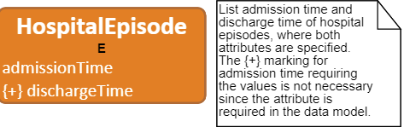 | PREFIX : <http://lumii.lv/ontologies/2016/mini-bkus-en#>  SELECT ?admissionTime ?dischargeTime WHERE{  ?E a :HospitalEpisode.  OPTIONAL{?E :admissionTime ?admissionTime.}  ?E :dischargeTime ?dischargeTime.}
Simple and attribute-based statistics
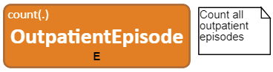 | PREFIX : <http://lumii.lv/ontologies/2016/mini-bkus-en#>  SELECT (COUNT(?E) AS ?E_COUNT) WHERE{  ?E a :OutpatientEpisode.}
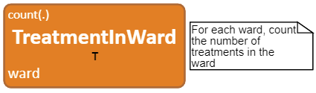 | PREFIX : <http://lumii.lv/ontologies/2016/mini-bkus-en#>  SELECT ?ward (COUNT(?T) AS ?T_COUNT) WHERE{  ?T a :TreatmentInWard.  OPTIONAL{?T :ward ?ward.}}  GROUP BY ?ward
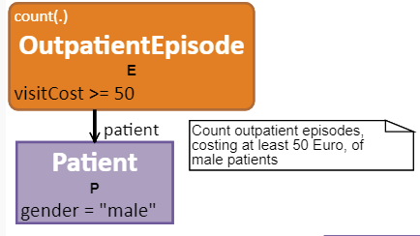 | PREFIX : <http://lumii.lv/ontologies/2016/mini-bkus-en#>  SELECT (COUNT(?E) AS ?E_COUNT) WHERE{  ?E a :OutpatientEpisode.  ?P a :Patient.  ?E :patient ?P.  FILTER(EXISTS{?E :visitCost ?visitCost.  FILTER(?visitCost >= 50)})  FILTER(EXISTS{?P :gender ?gender.  FILTER(STR(?gender) = "male")})}
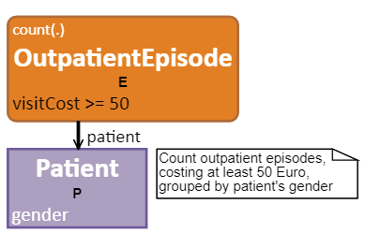 | PREFIX : <http://lumii.lv/ontologies/2016/mini-bkus-en#>  SELECT ?gender (COUNT(?E) AS ?E_COUNT) WHERE{  ?E a :OutpatientEpisode.  ?P a :Patient.  OPTIONAL{?P :gender ?gender.}  ?E :patient ?P.  FILTER(EXISTS{?E :visitCost ?visitCost.  FILTER(?visitCost >= 50)})}  GROUP BY ?gender
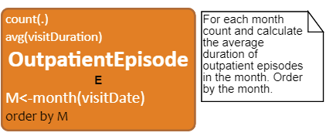 | PREFIX : <http://lumii.lv/ontologies/2016/mini-bkus-en#>  SELECT ?M (COUNT(?E) AS ?E_COUNT) (AVG(?visitDuration) AS ?visitDuration_AVG) WHERE{  ?E a :OutpatientEpisode.  OPTIONAL{?E a :OutpatientEpisode.  ?E :visitDate ?visitDate_1.  BIND(MONTH(?visitDate_1) AS ?M)}  OPTIONAL{?E :visitDuration ?visitDuration.}}  GROUP BY ?M  ORDER BY ?M
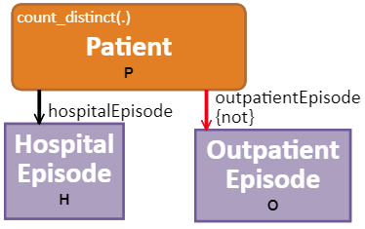 | PREFIX : <http://lumii.lv/ontologies/2016/mini-bkus-en#>  SELECT (COUNT(?P) AS ?P_COUNT) WHERE{  ?P a :Patient.  FILTER(EXISTS{?P :hospitalEpisode ?hospitalEpisode. })  FILTER(NOT EXISTS{?P :outpatientEpisode ?outpatientEpisode. })}
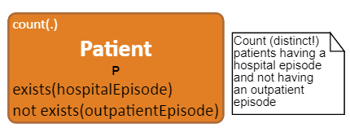 | PREFIX : <http://lumii.lv/ontologies/2016/mini-bkus-en#>  SELECT (COUNT(DISTINCT ?P) AS ?P_COUNT) WHERE{  ?P a :Patient.  FILTER NOT EXISTS{?O a :OutpatientEpisode.  ?P :outpatientEpisode ?O.}  ?H a :HospitalEpisode.  ?P :hospitalEpisode ?H.}
Subqueries: Statistics around data items (class instances)
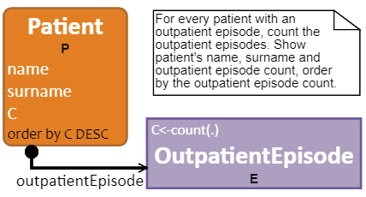 | PREFIX : <http://lumii.lv/ontologies/2016/mini-bkus-en#>  SELECT ?name ?surname ?C WHERE{  ?P a :Patient.  {SELECT ?P (COUNT(?E) AS ?C) WHERE{  ?E a :OutpatientEpisode.  ?P :outpatientEpisode ?E.}  GROUP BY ?P}  OPTIONAL{?P :name ?name.}  OPTIONAL{?P :surname ?surname.}}  ORDER BY DESC(?C)
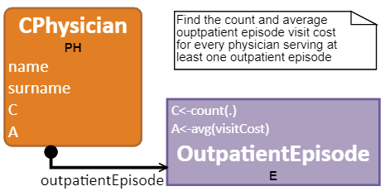 | PREFIX : <http://lumii.lv/ontologies/2016/mini-bkus-en#>  SELECT ?name ?surname ?C ?A WHERE{  ?PH a :CPhysician.  {SELECT ?PH (COUNT(?E) AS ?C) (AVG(?visitCost) AS ?A) WHERE{  ?E a :OutpatientEpisode.  OPTIONAL{?E :visitCost ?visitCost.}  ?PH :outpatientEpisode ?E.}  GROUP BY ?PH}  OPTIONAL{?PH :name ?name.}  OPTIONAL{?PH :surname ?surname.}}
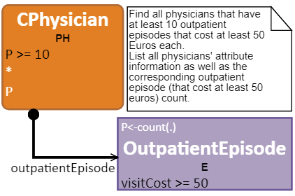 | PREFIX : <http://lumii.lv/ontologies/2016/mini-bkus-en#>  SELECT ?surname ?name ?personCode ?P WHERE{  ?PH a :CPhysician.  {SELECT ?PH (COUNT(?E) AS ?P) WHERE{  ?E a :OutpatientEpisode.  ?PH :outpatientEpisode ?E.  FILTER(EXISTS{?E :visitCost ?visitCost.  FILTER(?visitCost >= 50)})}  GROUP BY ?PH}  OPTIONAL{?PH :surname ?surname.}  OPTIONAL{?PH :name ?name.}  OPTIONAL{?PH :personCode ?personCode.}  FILTER(?P >= 10)}
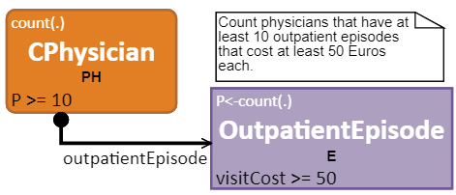 | PREFIX : <http://lumii.lv/ontologies/2016/mini-bkus-en#>  SELECT (COUNT(?PH) AS ?PH_COUNT) WHERE{  ?PH a :CPhysician.  {SELECT ?PH (COUNT(?E) AS ?P) WHERE{  ?E a :OutpatientEpisode.  ?PH :outpatientEpisode ?E.  FILTER(EXISTS{?E :visitCost ?visitCost.  FILTER(?visitCost >= 50)})}  GROUP BY ?PH}  FILTER(?P >= 10)}
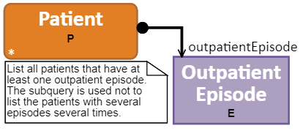 | PREFIX : <http://lumii.lv/ontologies/2016/mini-bkus-en#>  SELECT ?birthDate ?gender ?surname ?name ?personCode WHERE{  ?P a :Patient.  FILTER(EXISTS{?E a :OutpatientEpisode.  ?P :outpatientEpisode ?E.})  OPTIONAL{?P :birthDate ?birthDate.}  OPTIONAL{?P :gender ?gender.}  OPTIONAL{?P :surname ?surname.}  OPTIONAL{?P :name ?name.}  OPTIONAL{?P :personCode ?personCode.}}
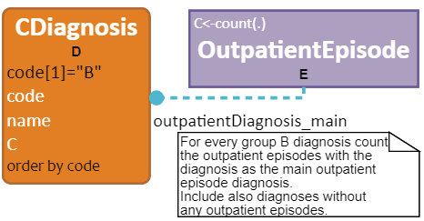 | PREFIX : <http://lumii.lv/ontologies/2016/mini-bkus-en#>  SELECT ?code ?name ?C WHERE{  ?D a :CDiagnosis.  {SELECT ?D (COUNT(?E) AS ?C) WHERE{  ?D a :CDiagnosis.  OPTIONAL{?E a :OutpatientEpisode.  ?E :outpatientDiagnosis_main ?D.}}  GROUP BY ?D}  OPTIONAL{?D :code ?code.}  OPTIONAL{?D :name ?name.}  FILTER(bif:substring(?code, 1, 1) = "B")}  ORDER BY ?code
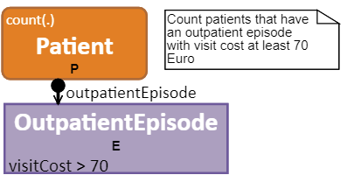 | PREFIX : <http://lumii.lv/ontologies/2016/mini-bkus-en#>  SELECT (COUNT(?P) AS ?P_COUNT) WHERE{  ?P a :Patient.  FILTER(EXISTS{?E a :OutpatientEpisode.  ?P :outpatientEpisode ?E.  FILTER(EXISTS{?E :visitCost ?visitCost.  FILTER(?visitCost > 70)})})}
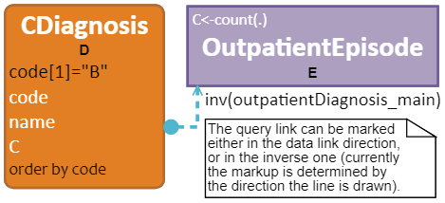 | PREFIX : <http://lumii.lv/ontologies/2016/mini-bkus-en#>  SELECT ?code ?name ?C WHERE{  ?D a :CDiagnosis.  {SELECT ?D (COUNT(?E) AS ?C) WHERE{  ?D a :CDiagnosis.  OPTIONAL{?E a :OutpatientEpisode.  ?D :outpatientDiagnosis_main ?E.}}  GROUP BY ?D}  OPTIONAL{?D :code ?code.}  OPTIONAL{?D :name ?name.}  FILTER(bif:substring(?code, 1, 1) = "B")}  ORDER BY ?code
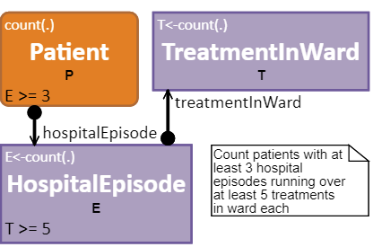 | PREFIX : <http://lumii.lv/ontologies/2016/mini-bkus-en#>  SELECT (COUNT(?P) AS ?P_COUNT) WHERE{  ?P a :Patient.  {SELECT ?P (COUNT(?E) AS ?E) WHERE{  ?E a :HospitalEpisode.  {SELECT ?E (COUNT(?T) AS ?T) WHERE{  ?T a :TreatmentInWard.  ?E :treatmentInWard ?T.}  GROUP BY ?E}  ?P :hospitalEpisode ?E.  FILTER(?T >= 5)}  GROUP BY ?P}  FILTER(?E >= 3)}
Advanced examples: expressions, condition links, free links and free nodes
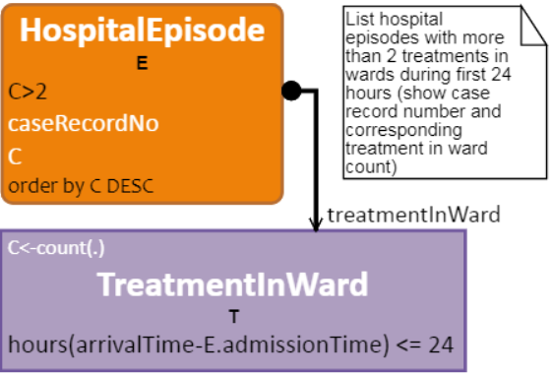 | PREFIX : <http://lumii.lv/ontologies/2016/mini-bkus-en#>  SELECT ?caseRecordNo ?C WHERE{  ?E a :HospitalEpisode.  {SELECT ?E (COUNT(?T) AS ?C) WHERE{  ?T a :TreatmentInWard.  ?E :treatmentInWard ?T.  FILTER(EXISTS{?T :arrivalTime ?arrivalTime.  ?E :admissionTime ?admissionTime_E.  FILTER(bif:datediff("hour", ?admissionTime_E, ?arrivalTime) <= 24)})}  GROUP BY ?E}  OPTIONAL{?E :caseRecordNo ?caseRecordNo.}  FILTER(?C > 2)}  ORDER BY DESC(?C)
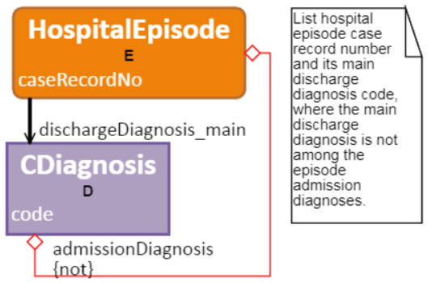 | PREFIX : <http://lumii.lv/ontologies/2016/mini-bkus-en#>  SELECT ?caseRecordNo ?code WHERE{  ?E a :HospitalEpisode.  OPTIONAL{?E :caseRecordNo ?caseRecordNo.}  ?D a :CDiagnosis.  OPTIONAL{?D :code ?code.}  ?E :dischargeDiagnosis_main ?D.  FILTER NOT EXISTS{?E :admissionDiagnosis ?D.}}
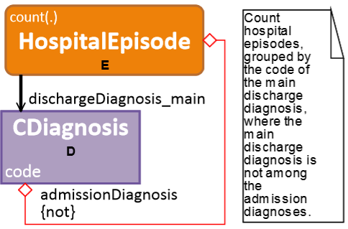 | PREFIX : <http://lumii.lv/ontologies/2016/mini-bkus-en#>  SELECT ?code (COUNT(?E) AS ?E_COUNT) WHERE{  ?E a :HospitalEpisode.  ?D a :CDiagnosis.  OPTIONAL{?D :code ?code.}  ?E :dischargeDiagnosis_main ?D.  FILTER NOT EXISTS{?E :admissionDiagnosis ?D.}}  GROUP BY ?code
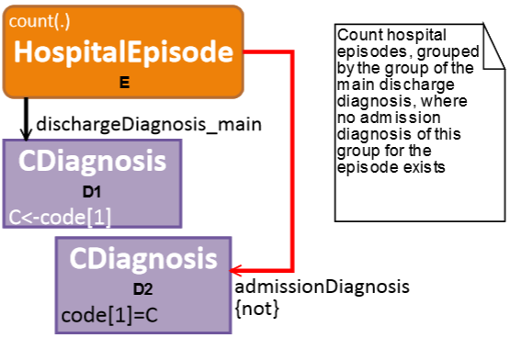 | PREFIX : <http://lumii.lv/ontologies/2016/mini-bkus-en#>  SELECT ?C (COUNT(?E) AS ?E_COUNT) WHERE{  ?E a :HospitalEpisode.  ?D1 a :CDiagnosis.  OPTIONAL{?D1 :code ?code_1.}  BIND(bif:substring(?code_1, 1, 1) AS ?C)  FILTER NOT EXISTS{?D2 a :CDiagnosis.  FILTER(EXISTS{?D2 :code ?code.  FILTER(bif:substring(?code, 1, 1) = ?C)})  ?E :admissionDiagnosis ?D2.}  ?E :dischargeDiagnosis_main ?D1.}  GROUP BY ?C
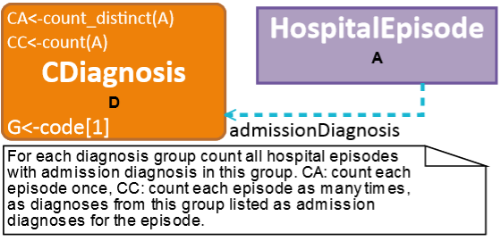 | PREFIX : <http://lumii.lv/ontologies/2016/mini-bkus-en#>  SELECT ?G (COUNT(DISTINCT ?A) AS ?CA) (COUNT(?A) AS ?CC) WHERE{  ?D a :CDiagnosis.  OPTIONAL{?D :code ?code_1.}  BIND(bif:substring(?code_1, 1, 1) AS ?G)  OPTIONAL{?A a :HospitalEpisode.  ?A :admissionDiagnosis ?D.}}  GROUP BY ?G
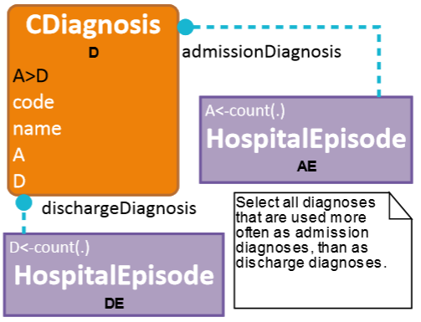 | PREFIX : <http://lumii.lv/ontologies/2016/mini-bkus-en#>  SELECT ?code ?name ?A ?D WHERE{  ?D a :CDiagnosis.  {SELECT ?D (COUNT(?DE) AS ?D) WHERE{  ?D a :CDiagnosis.  OPTIONAL{?DE a :HospitalEpisode.  ?DE :dischargeDiagnosis ?D.}}  GROUP BY ?D}  {SELECT ?D (COUNT(?AE) AS ?A) WHERE{  ?D a :CDiagnosis.  OPTIONAL{?AE a :HospitalEpisode.  ?AE :admissionDiagnosis ?D.}}  GROUP BY ?D}  OPTIONAL{?D :code ?code.}  OPTIONAL{?D :name ?name.}  FILTER(?A > ?D)}
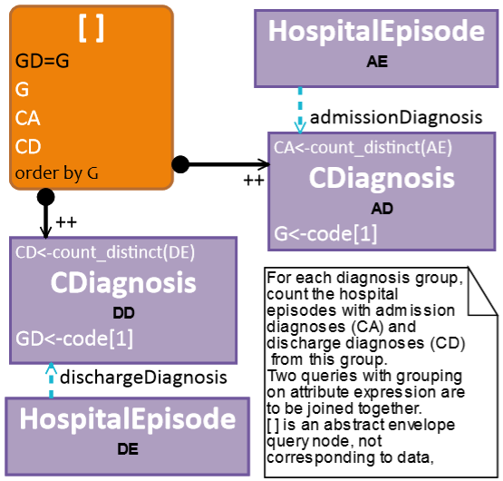 | PREFIX : <http://lumii.lv/ontologies/2016/mini-bkus-en#>  SELECT ?G ?CA ?CD WHERE{  {SELECT ?GD (COUNT(DISTINCT ?DE) AS ?CD) WHERE{  ?DD a :CDiagnosis.  OPTIONAL{?DD :code ?code_2.}  BIND(bif:substring(?code_2, 1, 1) AS ?GD)  OPTIONAL{?DE a :HospitalEpisode.  ?DE :dischargeDiagnosis ?DD.}}  GROUP BY ?GD}  {SELECT ?G (COUNT(DISTINCT ?AE) AS ?CA) WHERE{  ?AD a :CDiagnosis.  OPTIONAL{?AD :code ?code_1.}  BIND(bif:substring(?code_1, 1, 1) AS ?G)  OPTIONAL{?AE a :HospitalEpisode.  ?AE :admissionDiagnosis ?AD.}}  GROUP BY ?G}  FILTER(?GD = ?G)}  ORDER BY ?G
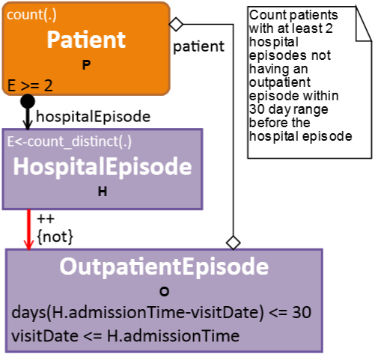 | PREFIX : <http://lumii.lv/ontologies/2016/mini-bkus-en#>  PREFIX xsd: <http://www.w3.org/2001/XMLSchema#>  SELECT (COUNT(?P) AS ?P_COUNT) WHERE{  ?P a :Patient.  {SELECT ?P (COUNT(DISTINCT ?H) AS ?E) WHERE{  ?H a :HospitalEpisode.  FILTER NOT EXISTS{?O a :OutpatientEpisode.  FILTER(EXISTS{?H :admissionTime ?admissionTime_H.  ?O :visitDate ?visitDate.  FILTER(bif:datediff("day", xsd:dateTime(?visitDate), ?admissionTime_H) <= 30)})  FILTER(EXISTS{?O :visitDate ?visitDate_1.  ?H :admissionTime ?admissionTime_H_1.  FILTER(?visitDate_1 <= ?admissionTime_H_1)})  ?O :patient ?P.}  ?P :hospitalEpisode ?H.}  GROUP BY ?P}  FILTER(?E >= 2)}
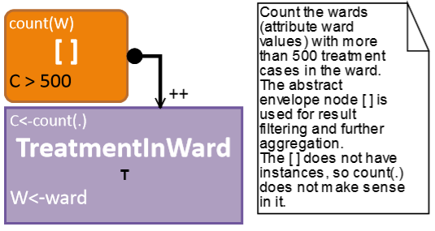 | PREFIX : <http://lumii.lv/ontologies/2016/mini-bkus-en#>  SELECT (COUNT(?W) AS ?W_COUNT) WHERE{  {SELECT ?W (COUNT(?T) AS ?C) WHERE{  ?T a :TreatmentInWard.  OPTIONAL{?T :ward ?W.}}  GROUP BY ?W}  FILTER(?C > 500)}
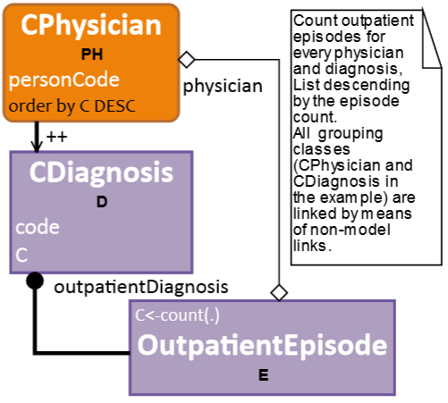 | PREFIX : <http://lumii.lv/ontologies/2016/mini-bkus-en#>  SELECT ?personCode ?code ?C WHERE{  ?PH a :CPhysician.  OPTIONAL{?PH :personCode ?personCode.}  ?D a :CDiagnosis.  {SELECT ?D ?PH (COUNT(?E) AS ?C) WHERE{  ?E a :OutpatientEpisode.  ?E :outpatientDiagnosis ?D.  ?E :physician ?PH.}  GROUP BY ?D ?PH}  OPTIONAL{?D :code ?code.}}  ORDER BY DESC(?C)

